Medicaid CMS application Update - Migration to Open Source
Deployment Guide

Revision History
Author | Revision Number | Date
TCSASSEMBLER | 1.0 | 01.15.2015

Medicaid CMS application Update - Migration to Open Source 1
1. Deployment Instructions 3
2. Organization of Submission 3
3. Application Setup 3
3.1 Software Stack 3
3.2 Database Setup 3
3.2.1 MITA 3
3.2.2 CMS 3
3.3 JBoss Setup 3
3.4 Build Scripts Setup 3
4. Deployment Instructions 4
5. Starting 5
6. Verification 5
7. Resource Contact List 5

Deployment Instructions

Organization of Submission

- docs - the directory containing this document
- pesp-8.5 – contains the pesp web app
- pesp-8.5-ext-srcs – contains the pesp external sources web services

Application Setup

Software Stack

    - PostgreSQL 9

- Please download from PostgreSQL and install per product documentation.

    - Jboss AS 5.1.0.GA

- Download the software from JBoss and install per product documentation. This guide refers to the application server installation folder as <appserver.dir>

Database Setup

Create two databases:

MITA

Run pesp-8.5-ext-srcs/db/mita3_postgres.sql

CMS

Run pesp-8.5/db/mpse-clean-setup_postgres.sql

JBoss Setup

Open docs/jboss/deploy/mail-service.xml and change to match a valid smtp configuration.
Copy the contents of docs/jboss to <appserver.dir>/server/<yourserverconfig>/

Build Scripts Setup

    - Pesp-8.5-ext-srcs/build.xml

The following targets are available:

build-core Builds the core archive
build-ejb Builds the EJB archive
build-war Builds the startup web archive
clean Removes all generated files
dist Creates EAR distribution artifact
deploy-netstudy-mocks Deploys a mock version of the NET Study web service
netstudy-generate-client Regenerates the NET Study client
test Runs the Web service tests
undeploy-netstudy-mocks Undeploys the mock version of the NET Study web service
dist-ds Deploys the postgres datasource to JBoss

    - Pesp-8.5-ext-srcs/build.properties

jboss.home – location of jboss
jboss.config – jboss server config
jdbc.url – database url
jdbc.user – database user
jdbc.pass– database password

    - Pesp-8.5/build.xml

The following targets are available:

build-ejb Builds the EJB archive
build-war Builds the startup web archive
clean Removes all generated files
dist Creates EAR distribution artifact
deploy-ds Deploys the postgres datasource to JBoss

    - Pesp-8.5/build.properties

jboss.home – location of jboss
jboss.config – jboss server config
jdbc.url – database url
jdbc.user – database user
jdbc.pass– database password

Configuration Files
    - Pesp-8.5-ext-src/services/src/main/resources/META-INF/ejb-jar.xml

Contains configuration needed by each of the services

Entry | Description | Beans
mita/config/URL | URL for the external source | All *DAOBean classes
mita/config/disciplineURL | Discipline List external URL | ChiropracticLicenseDAOBean
mita/config/loginURL | External Login URL | NursingLicenseDAOBean
mita/config/username | External Login User | NursingLicenseDAOBean
mita/config/password | External Login Password | NursingLicenseDAOBean
mita/config/verificationURL | Verification URL | OIGDAOBean
mita/config/exclusionURL | Exclusion type list URL | OIGDAOBean
mita/config/providerTypeId | The id of the provider type | All subclasses of BaseProviderScreeningDAO
mita/config/netStudyWebServiceUrl | The net study web service url
mita/config/denialStatusesConfig | The denial statuses for net study
mita/config/inputDirectory | The input directory used for file processing | DeathMasterSchedulerBean  PECOSSchedulerBean
mita/config/archiveDirectory | The archive directory used for file processing | DeathMasterSchedulerBean and PECOSSchedulerBean
mita/config/intervalDuration | The interval duration to run for batches | DeathMasterSchedulerBean and PECOSSchedulerBean

    - Pesp-8.5/services/src/main/resources/cms.properties

CMS Configurations

Entry | Description
export.pdf.folder | The pdf export folder.
filenet.folder | The file net folder.

Deployment Instructions

- Setup postgres and jboss per instructions above
- Switch to pesp-8.5 folder
- Execute “ant dist deploy-ds”
- Switch to pesp-8.5-ext-srcs folder
- Execute “ant dist dist-ds”

Starting

To start the app run ./run.sh or run.bat in <appserver.dir>/bin

Verification
The wsdl generated can be verified like this:

- Open http://localhost:8080/cms-ext/ws/BBHTLicenseService?wsdl

Open http://localhost:8080/cms

- Login as localadmin with password “localadmin”

After login, you should see the dashboard:

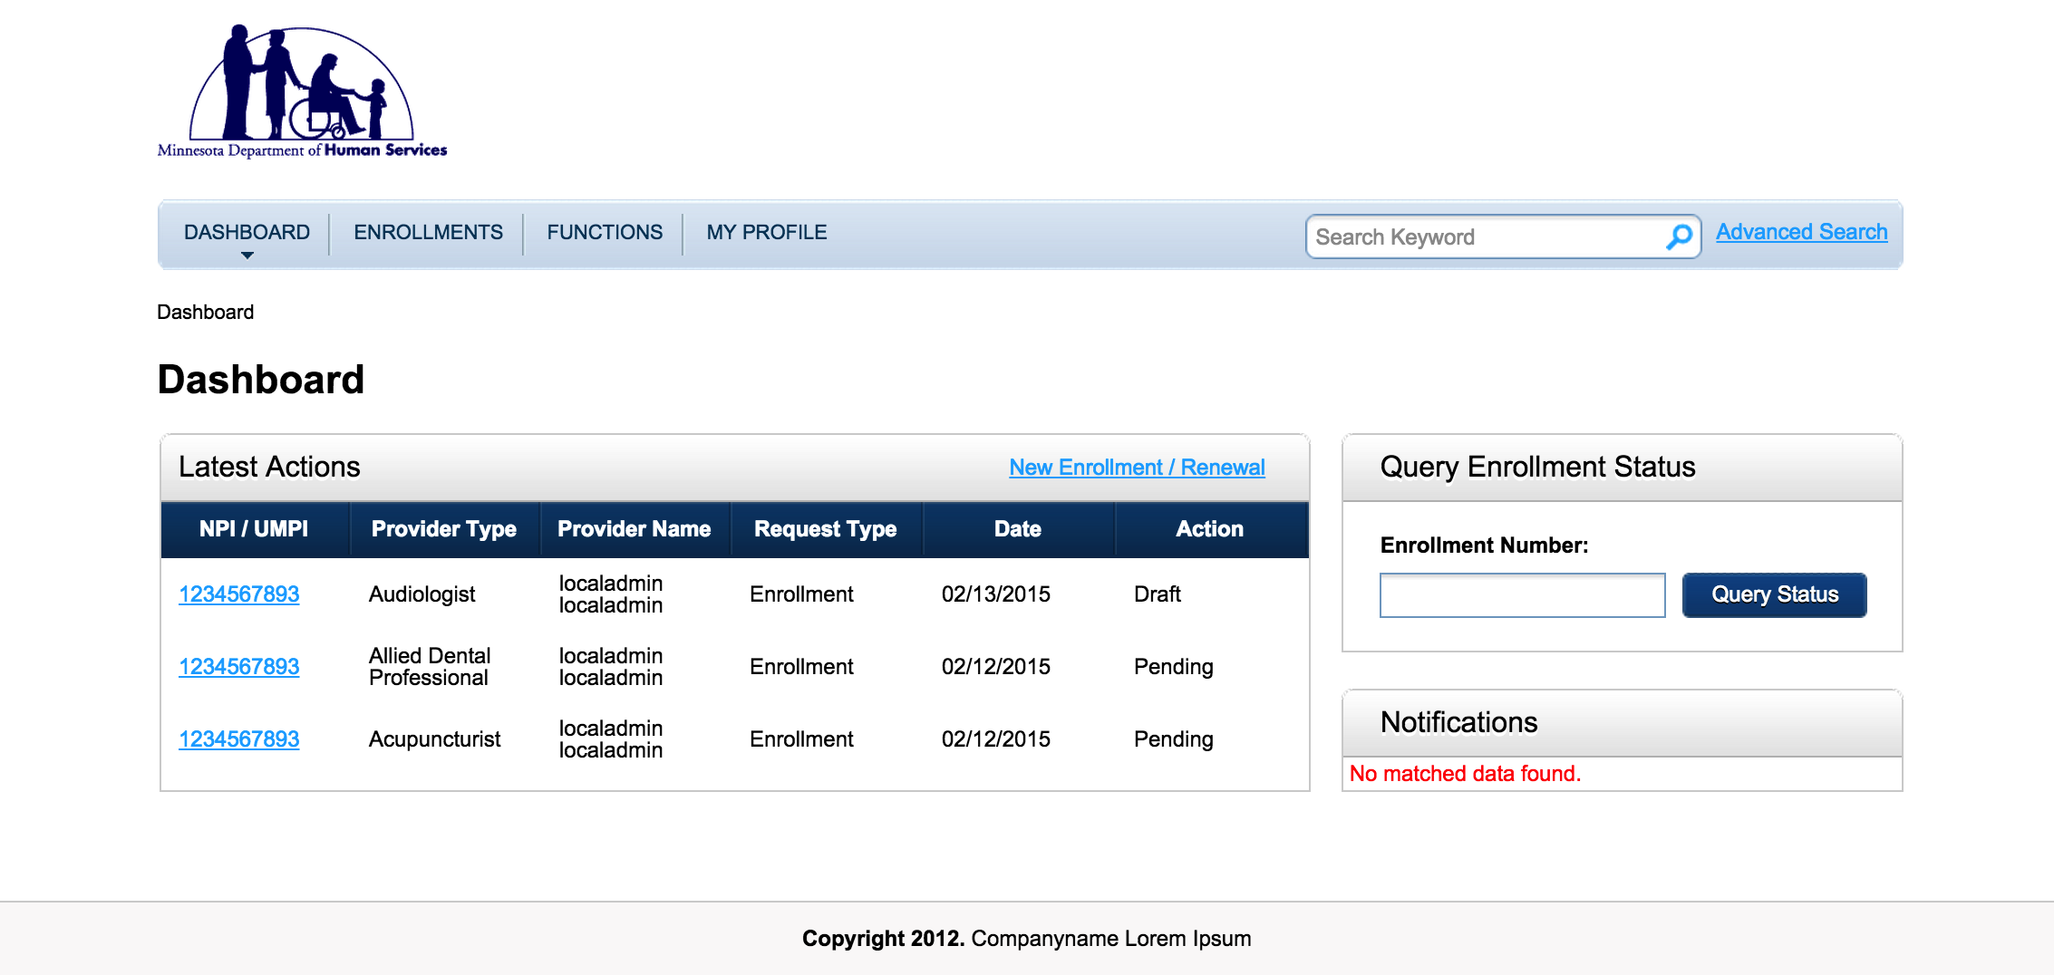

(Note, when login for the first time, there is no data so you will see an empty list).

Click ‘New Enrolment/Renew’:

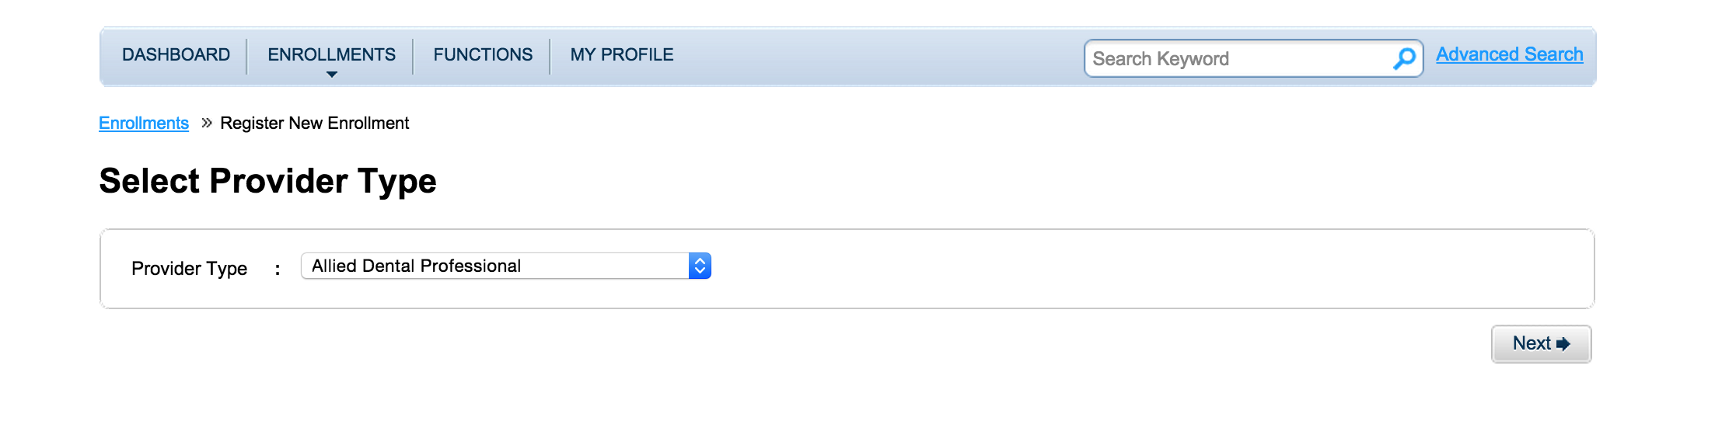

Select a provider type, and then click ‘Next’:

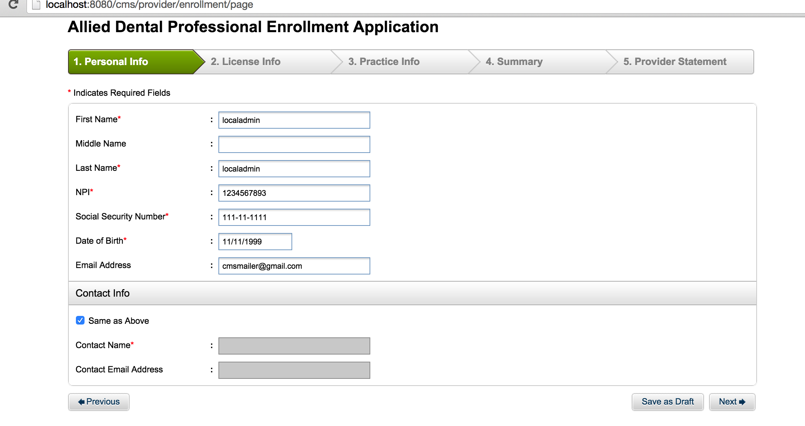

Input some valid/invalid values and click ‘Next’, if there is validation error, it will be shown. Follow all the steps until seeing the following screen (Step 4, Summary):

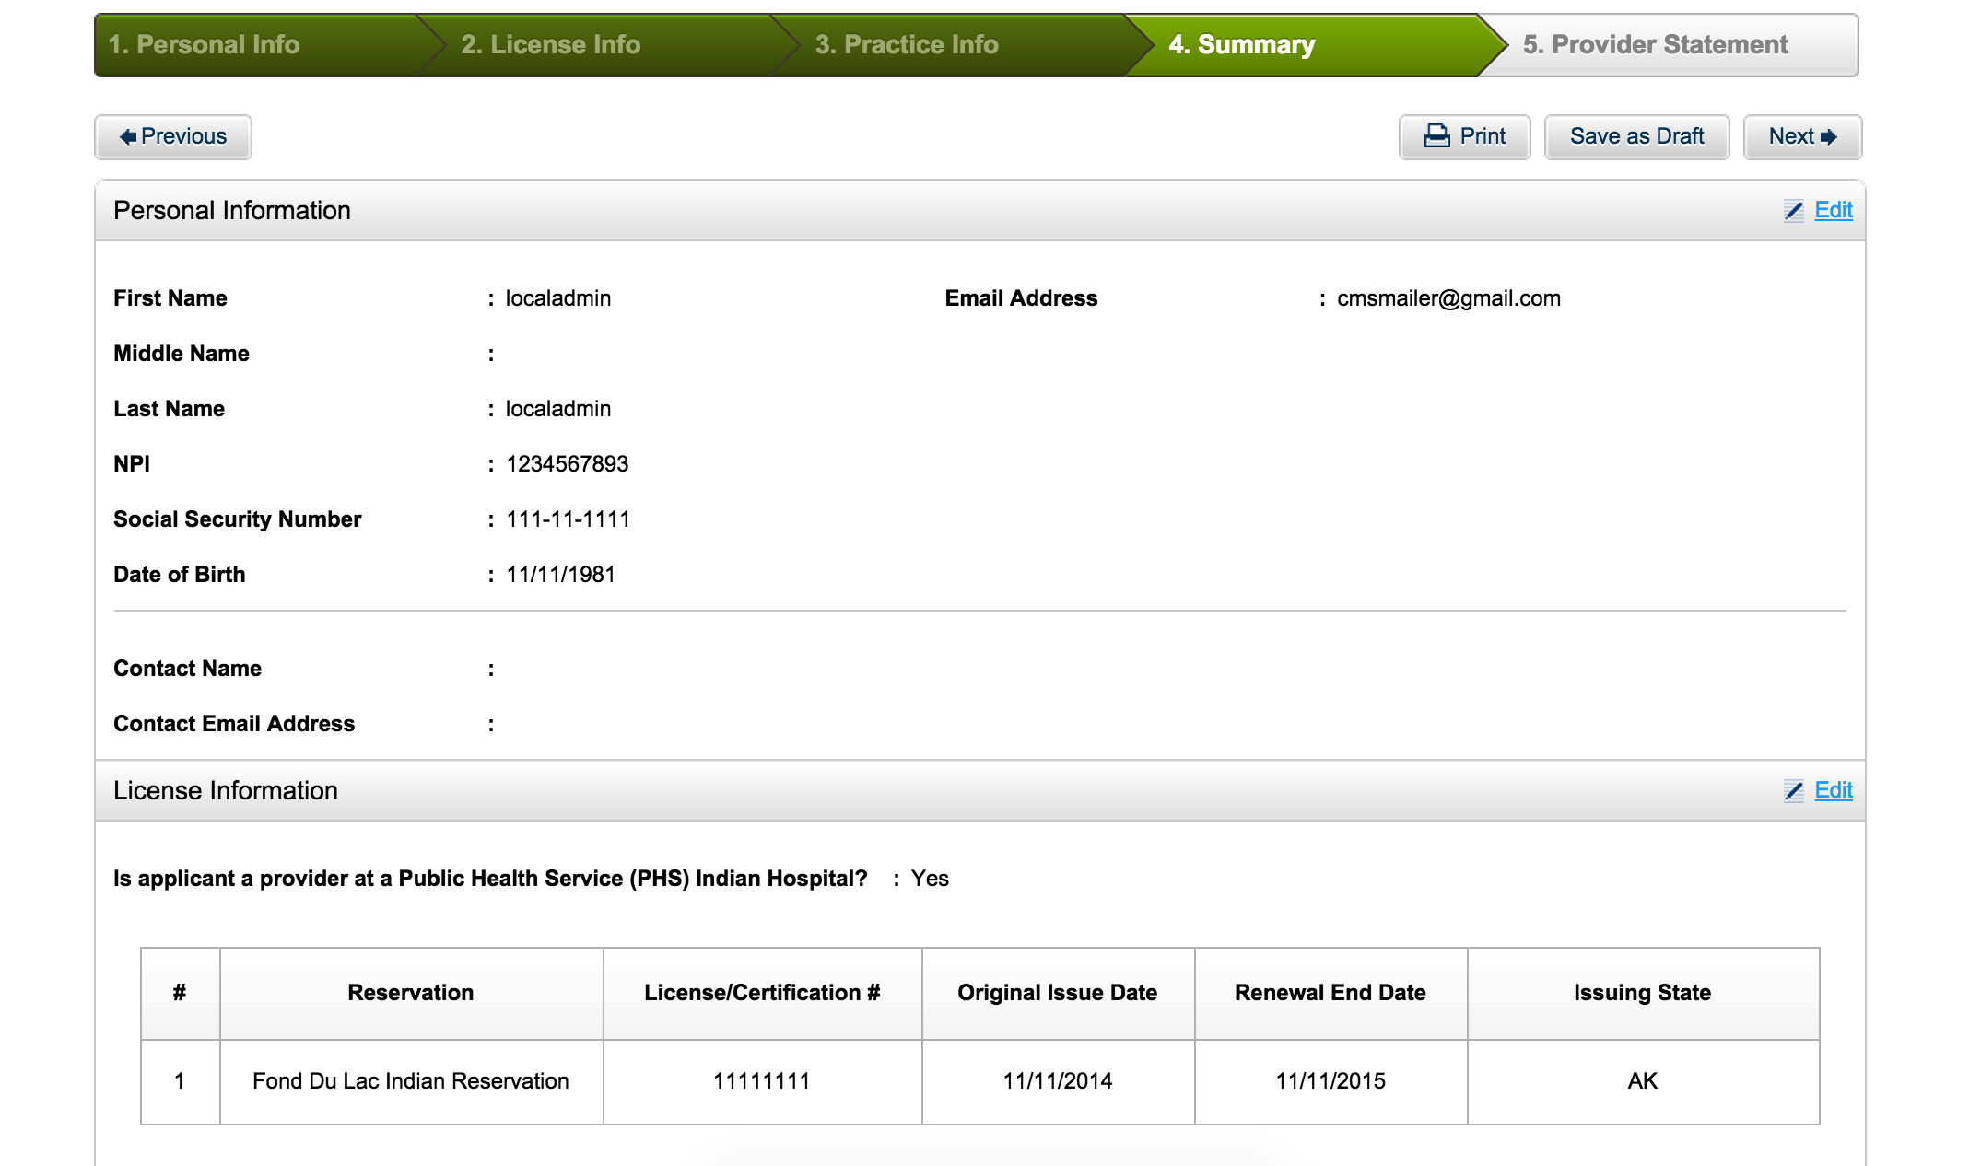

Click ‘Save as Draft’, then go back to dashboard. You will see this as a draft. Click the link , it redirects to the summary screen as above again. Now click ‘Next’:

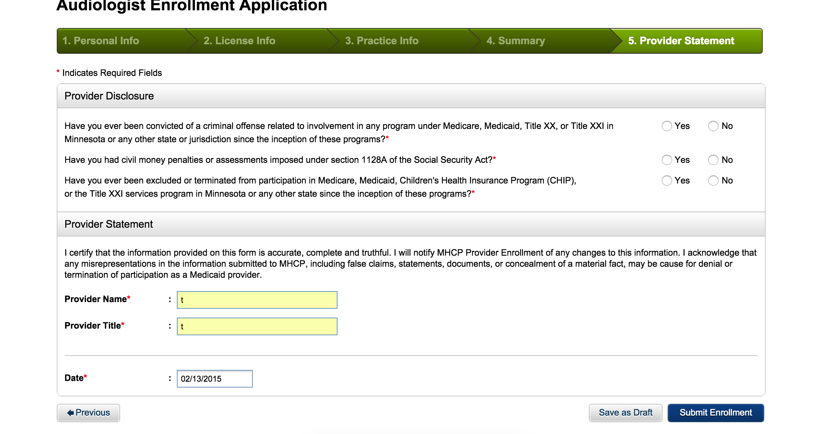

Input valid values (select No for all three questions), and click ‘Submit Enrolment’, you can see that the enrolment can be submitted without error.

On main page, click ‘Functions’.

Note, ‘Add Provider Type’ still not works, but this is an existing error in WAS version.

Play with all the functions, you will find they all work now.

Resource Contact List

Name | Resource Email
TCSASSEMBLER

